****Physics 11, 2019**

**Validation Test: Latent Heat Experiment**

Name : ____________________ Mark: _______/15

1. Define the term “Latent Heat”.

|  |
| --- |
|  |
|  |

**[1 Mark]**

1. Explain in terms of internal energy why the temperature does not increase during a change of phase?

|  |
| --- |
|  |
|  |
|  |
|  |
|  |
|  |
|  |

**[ 4 marks]**

1. A student conducted a similar experiment to the one that you did, but used a polystyrene cup instead of a calorimeter to hold the mixture. For the purpose of this question, you may assume the cup did not absorb any heat and its mass has already been removed from the results below.

Use the student’s partial data to calculate the **experimental value for the latent heat of fusion of ice.**

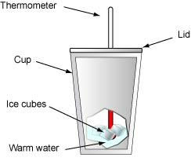

|  |  |
| --- | --- |
| Mass of Water in cup | 200g |
| Mass of Water plus ice in cup | 225g |
| Mass of ice |  |
| Initial temp (ice) | 0º C |
| Initial temp (water) | 50 º C |
| Final temp (water) | 35 º C |
| c (water) | 4180 J kg-1K-1 |
| c (ice) | 2100 J kg-1K-1 |

**[5 Marks]**

1. An ice cube is in the fridge at a temperature of -10 $°$ C. Heat is applied to the ice cube. Assuming heat is applied at a constant rate draw the heating curve showing the ice cube increasing in temperature from -10 $°$ C to steam at 120 $°$ C. Label each section of the graph and show the appropriate formulas.